Exercise 3.1 (skin depth of metals)
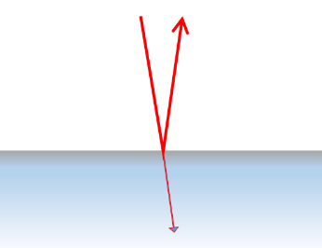
In the low frequency range ($ω/Γ≪1)$ the reflectance of metals is very high and approaches 1 for metals with high conductivity. Nevertheless light is transmitted through the metal layer and strongly attenuated. The penetration depth is called skin depth.
- Provide an expression for the skin depth δ of a metal as a function of plasma frequency $ω_{p}$ and relaxation time $τ$. Introduce the DC conductivity $σ_{0}$ to replace $ω_{p}$ and $τ$ in this expression.
- Determine the skin depth δ for aluminum for the incoming light frequencies of 100 MHz as well as ${10}^{15}$ Hz using the DC conductivity of $σ_{0}=3.69∙{10}^{7}$Ω⁻¹m⁻¹ for aluminum.
- Compare metallic reflection to the phenomenon total reflectance (compare the wavelength to the penetration depth/skin depth in both cases).
Exercise 3.2 (Plasmon absorption and scattering of metal nanoparticles)
Interaction of light with small metal nanoparticles at the resonance frequency result in the excitation of surface plasmons leading to both absorption and scattering.
- From the absorption cross section, determine the resonance frequency of small metallic nanospheres.
Hint: For the metal use the dielectric function derived from the Drude Zener model. Surface plasmon resonance occurs close to the bulk plasma frequency, therefore $ω/Γ≫1$ applies.
- Determine the wavelength of maximum absorption for small (< 10 nm diameter) aluminum nanospheres suspended in ethanol (estimate the plasma frequency of aluminum from the reflectance vs wavelength figure in the lecture notes).
- Calculate the maximum absorption wavelength for Ag and Au nanospheres suspended in water by obtaining the plasma frequency from the DC conductivity (Au: $4.5∙{10}^{7}$Ω⁻¹m⁻¹ , Ag: $6.3∙{10}^{7}$Ω⁻¹m⁻¹) and relaxation times (Au: $3∙{10}^{-14}$s⁻¹, Ag:$4∙{10}^{-14}$s⁻¹). Discuss your results.
